Steps to deploy AWS Lambda function in VS Code:

1. Install AWS toolkit extension in VS Code

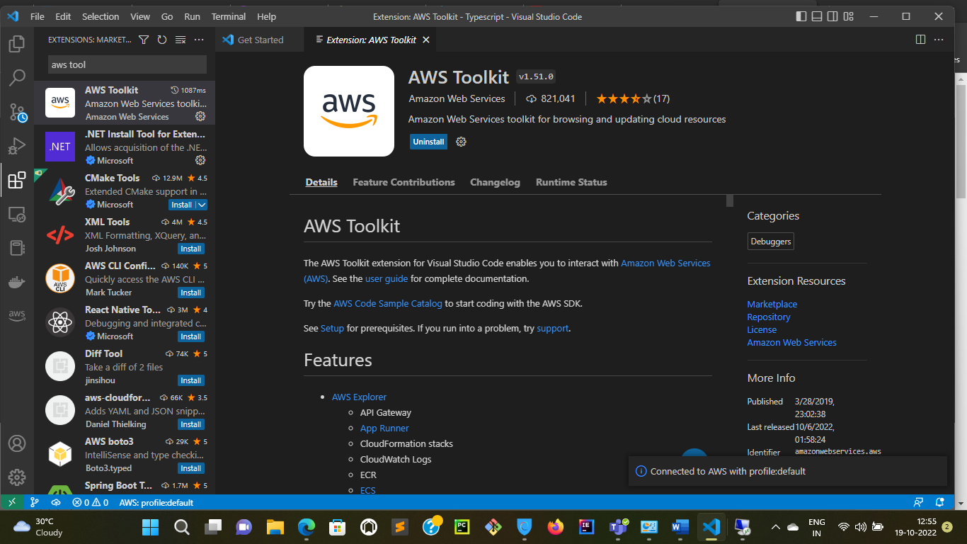

1. There are three dependencies in order to deploy AWS Lambda function

* Download AWS SAM CLI
* Docker should be Installed
* Authenticate with AWS

1. After installing AWS Toolkit extension you will see AWS logo to left side corner as shown below

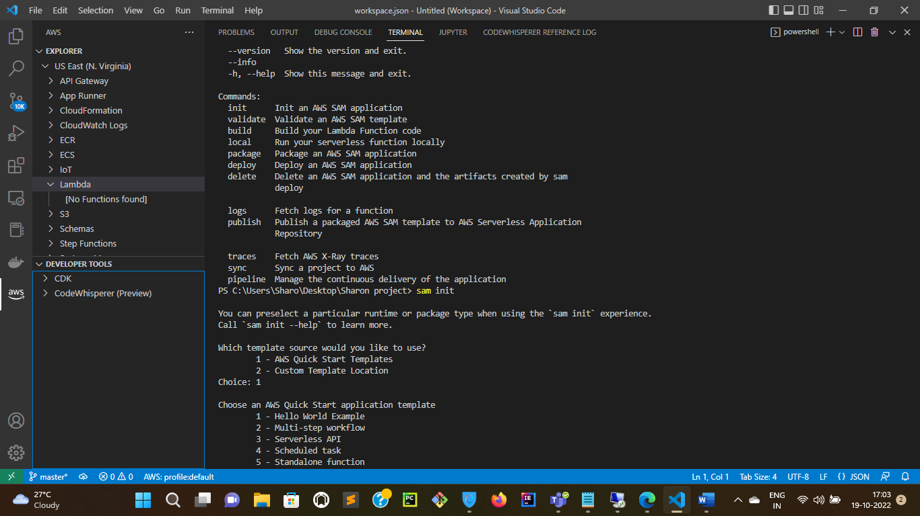

1. Now right click on Lambda then you will see following options

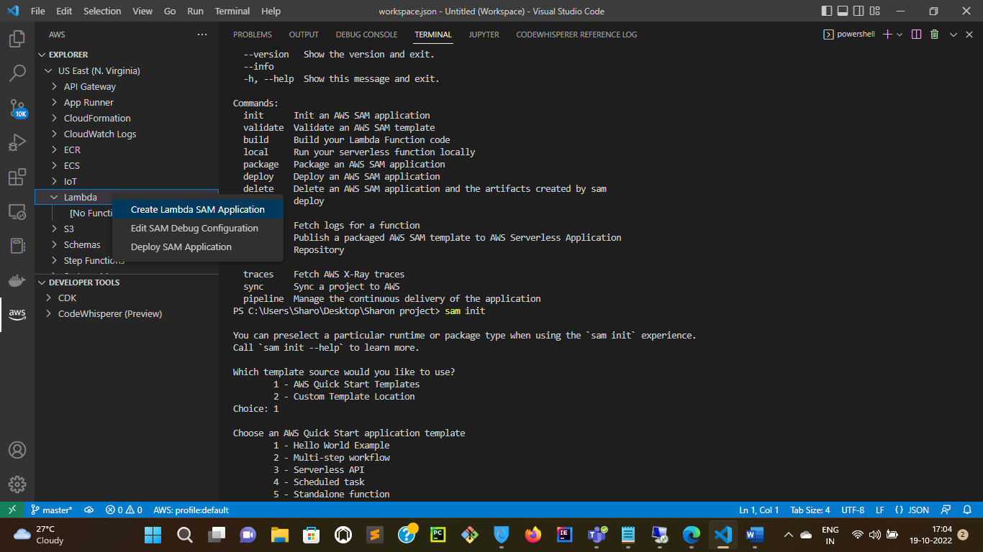

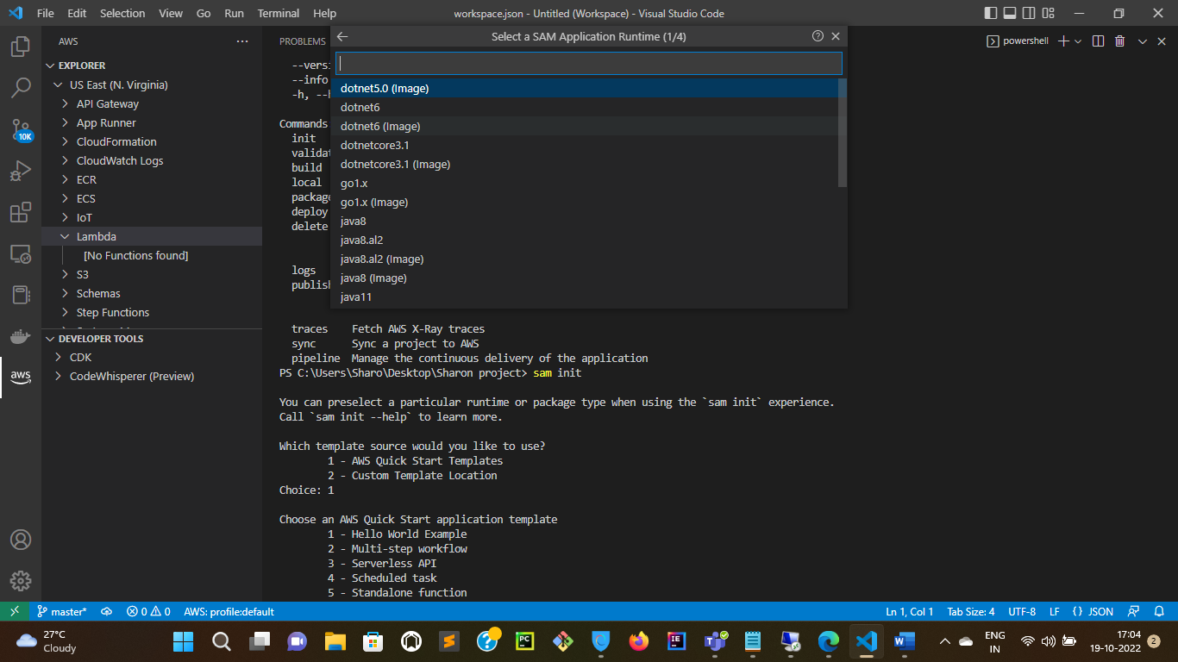

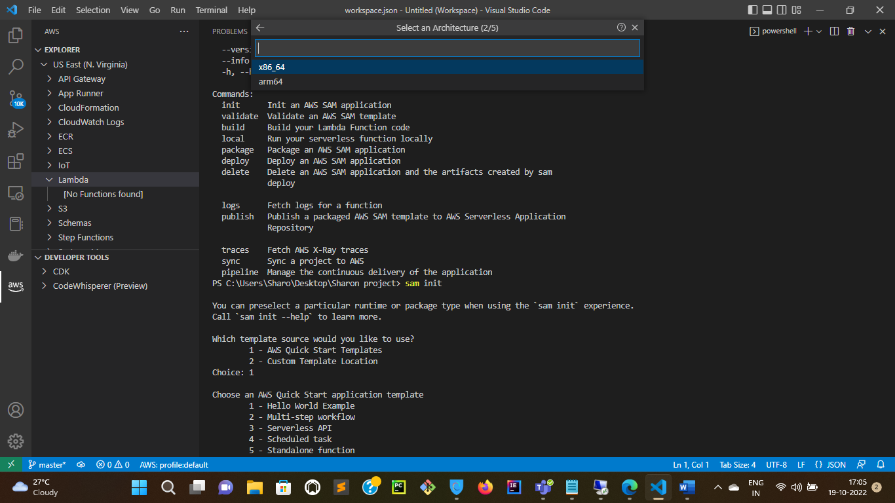

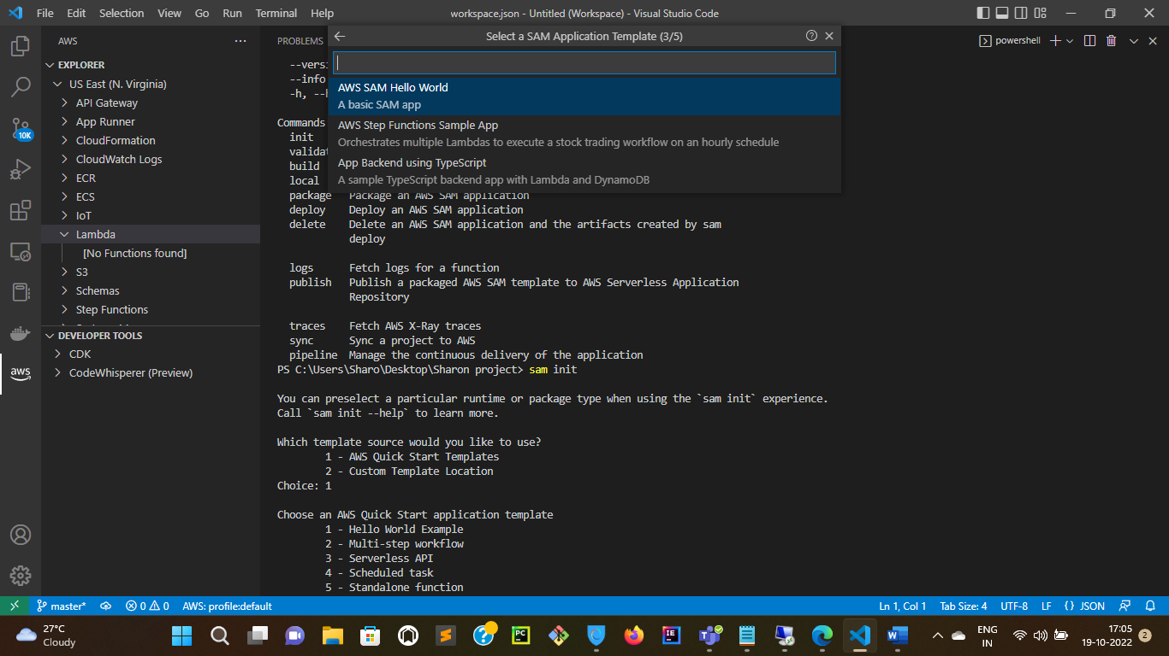

1. Create a folder in your local machine and select the folder that you have created in this step

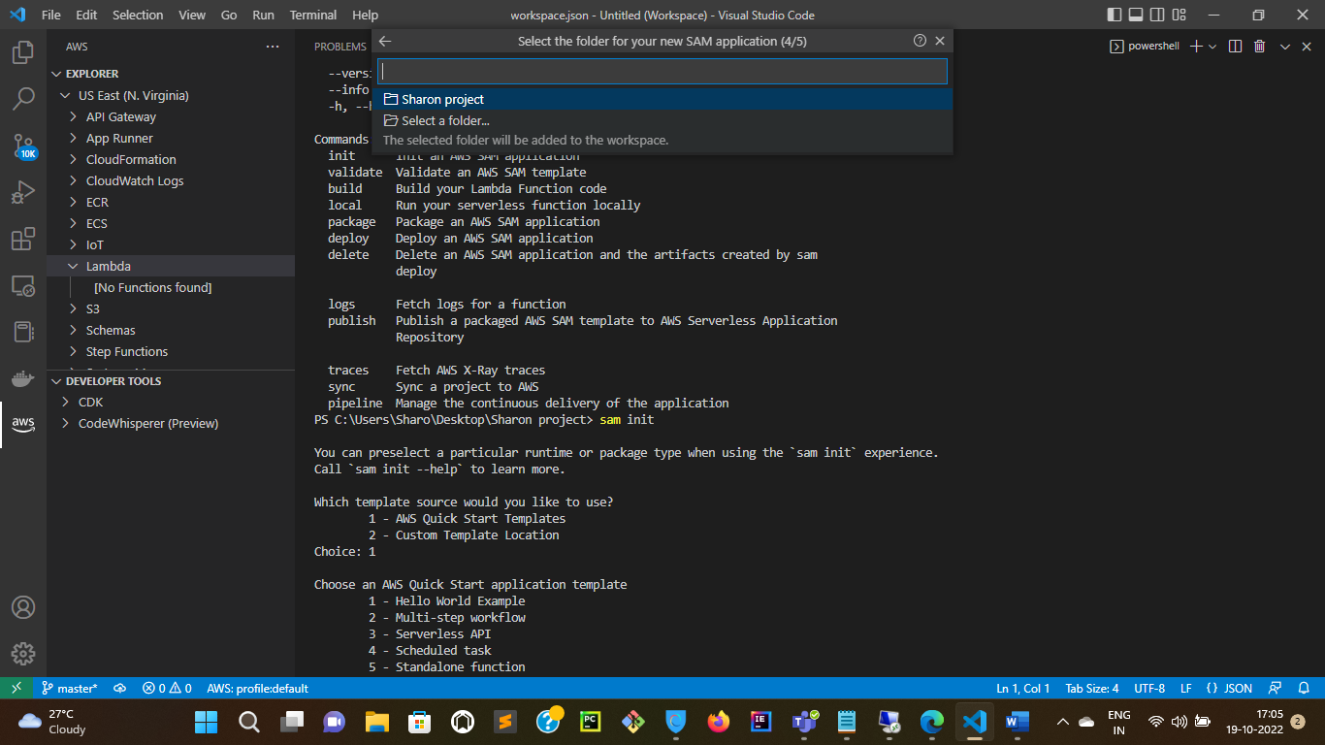

1. Go to the terminal now and follow the commands as below

* Sam -h
* Sam init
* Sam build
* Sam deploy –guided

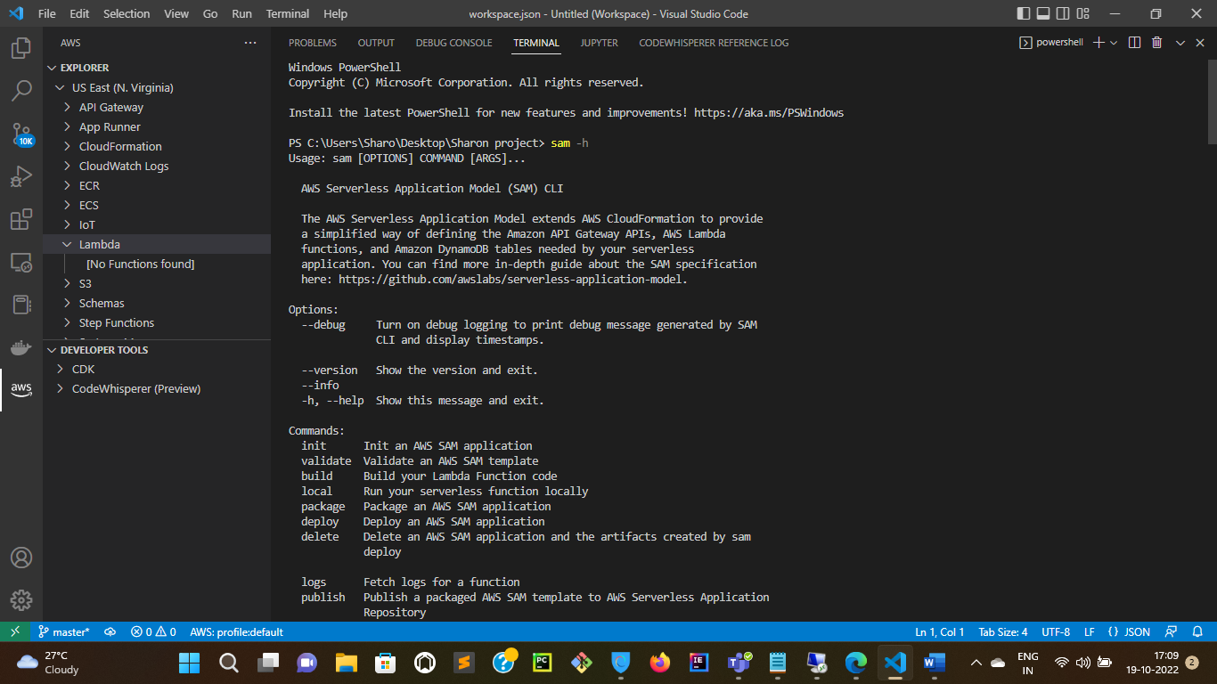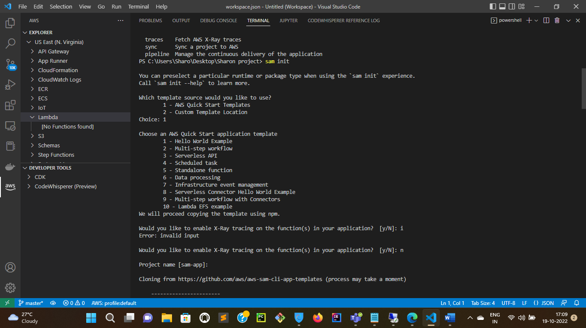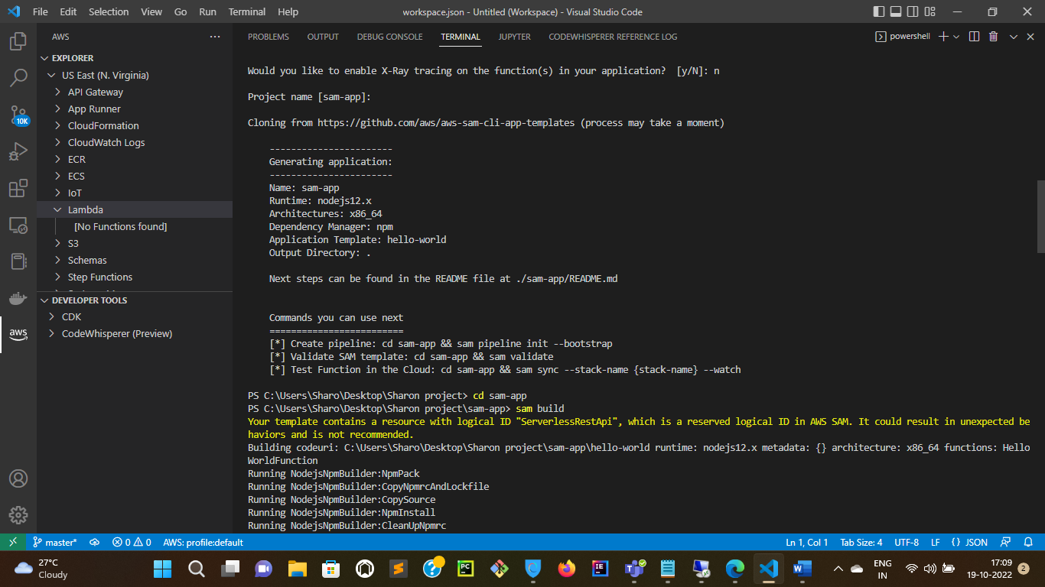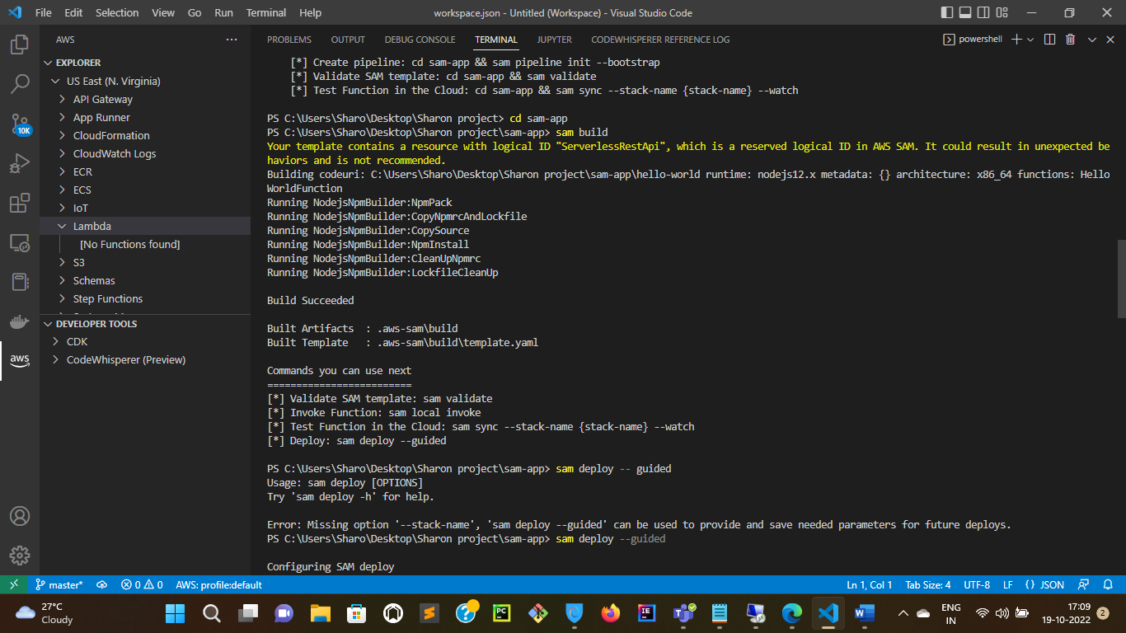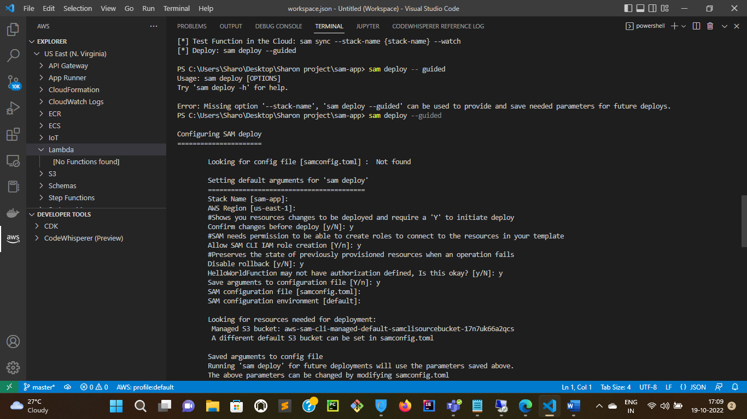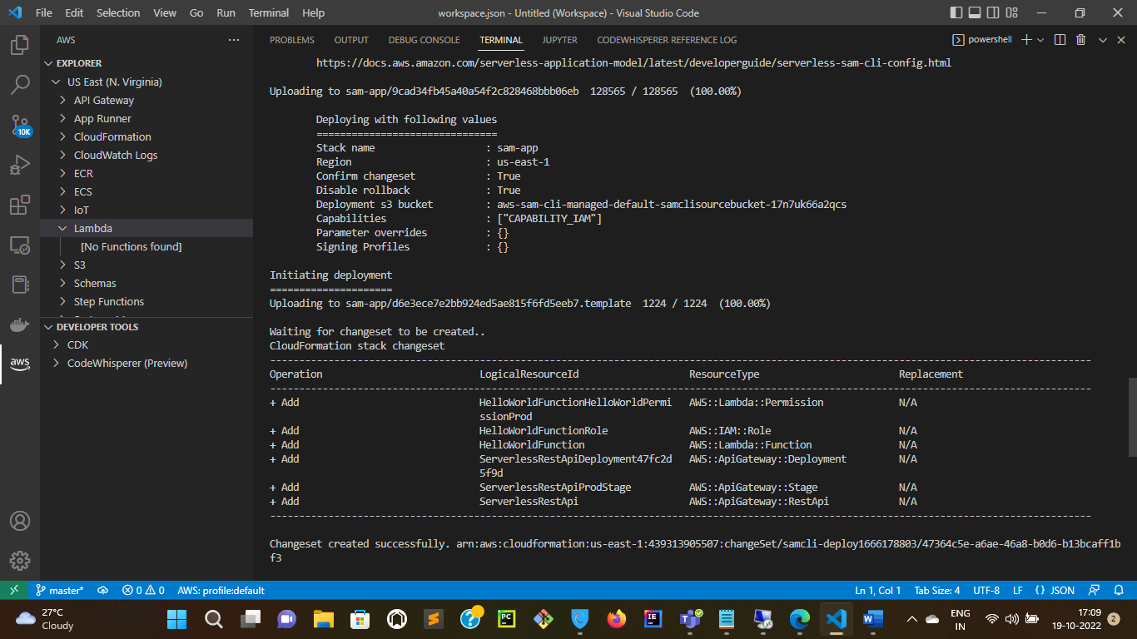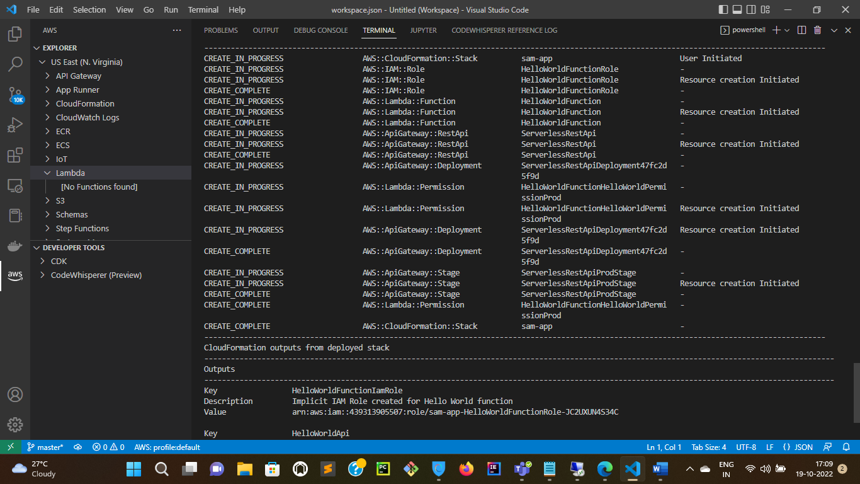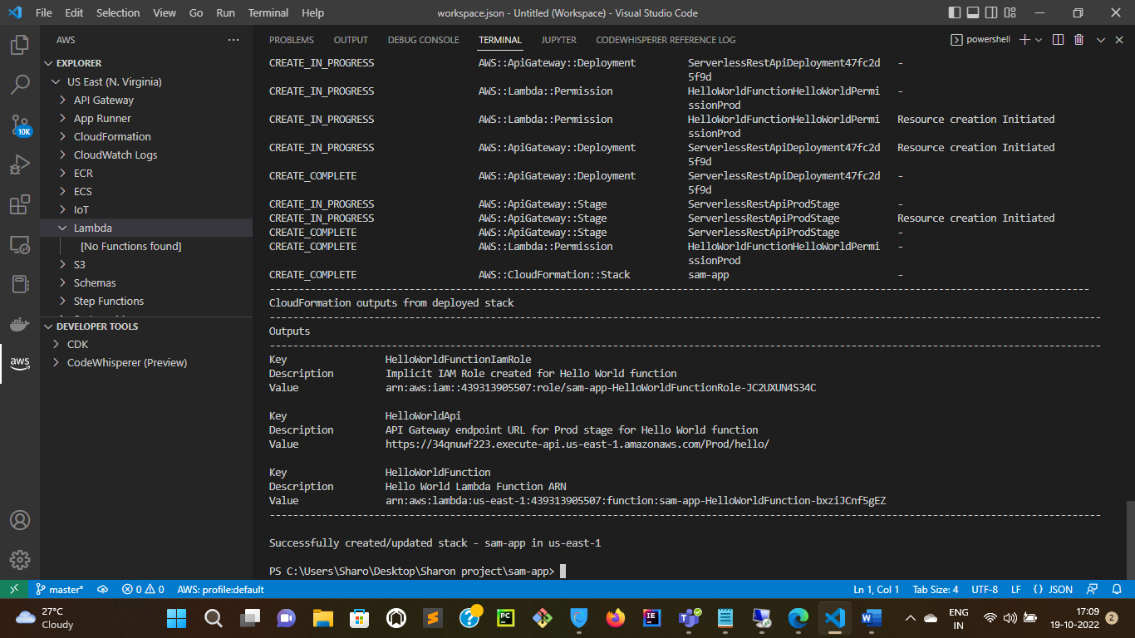

1. Login into AWS Management Console and check if Lambda function is created.

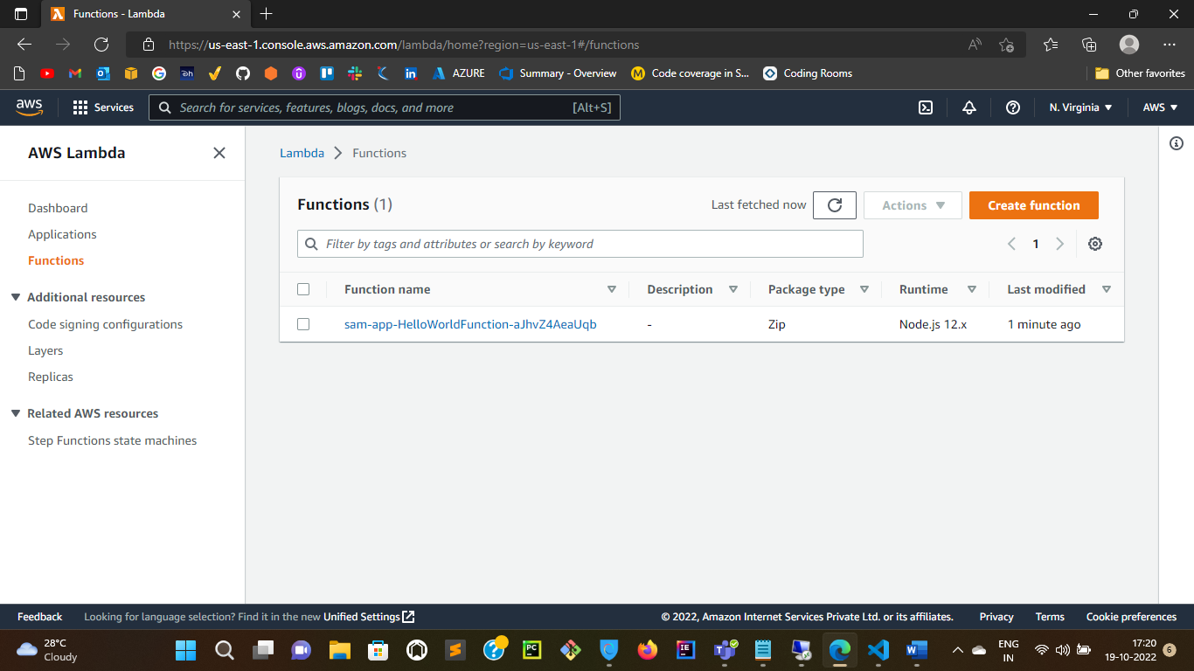

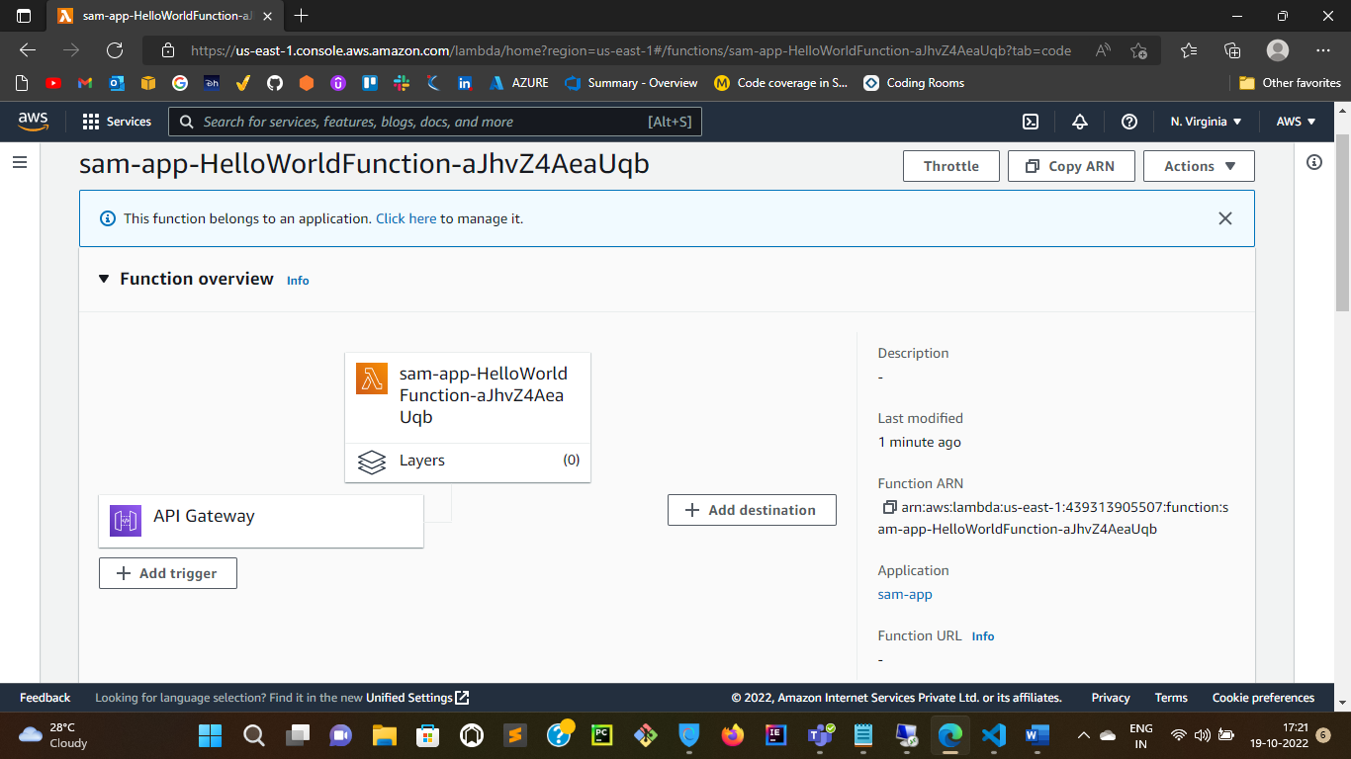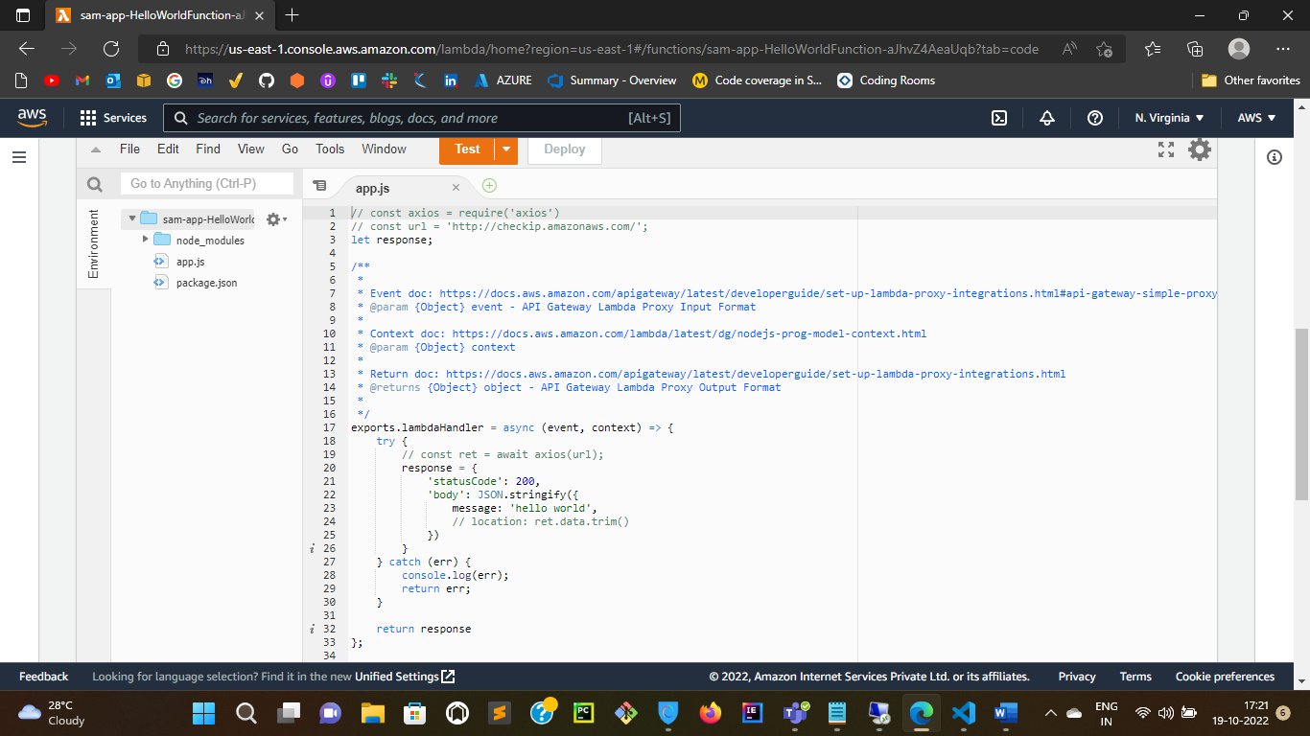

1. Use command” sam delete” to delete the Lambda function from the AWS console